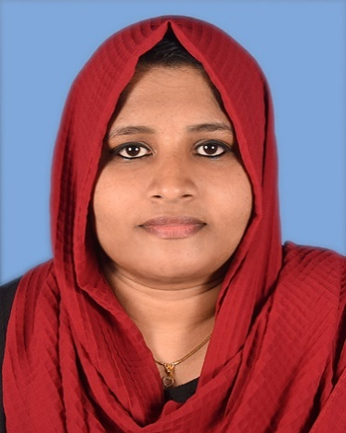

FASNA MM

**DEVELOPER**

About Me

I am an organized and hardworking post graduate in Computer Application, looking to secure a position where I can efficiently contribute my skills and abilities for the growth of the organization.



+918111802592

# [fasnayakoob@gmail.com](mailto:fasnayakoob@gmail.com)



# PERSONAL DETAILS

ADDRESS:

KUZHUPPILLY HOUSE

# SKILLS

* C, C++, JAVA
* HTML5, CSS3, JAVASCRIPT
* BOOTSTRAP5, DJANGO
* MYSQL, POSTGRESQL
* GIT
* MS OFFICE

# EXPERIENCE

* **OFFICE STAFF (2020-2022)**

MM TRADERS EXPORTING COMPANY

ALUVA

ERNAKULAM

# EDUCATION

NOCHIMA

COMBARA

NAD P.O

ALUVA

ERNAKULAM

PIN: 683563

NATIONALITY: INDIAN

DATE OF BIRTH: 16-07-1992

# LANGUAGE

English

Hindi Malayalam

# HOBBIES

Cooking

Drawing

Gardening

# Master of Computer Application 2013-2016

## MG University

## MES College Marampaly

## BSC Mathematics

## 2010-2013

## MG University

## MES College Marampaly

## Higher Secondary

## 2008-2010

## Govt.HSS Muppathadam

## SSLC Kerala Board of Examination

## 2008

## Little Flower High School, Panayikulam

# CERTIFICATIONS

* **Python and Django (December 2023):**

Certifiedin **Python** using **Django**.

Avodha EduTech Pvt.Ltd

Infopark, Ernakulam

HOBBIES

ggggggggggggggggggggggggggggggggggggggggggggggggggggggggggggggggggggggggggggggggggggggggggggggggggggggggggggggggggggggggggggggggggggggggggggggggggggggggg

HOBBIES

jjjjjjjjjjjjjjjkkkkkkkkkkkkkkkkkkkkkkkkkkkkkkkkkkkkkkkkkkkkkkkkkkkkkkkkkkkkkkk